Long Bennington Gardening Club - VPA

Day Trip to Breezy Knees Garden
Near York
Tuesday 26th July 2022

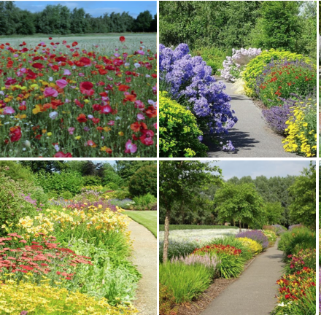
8.30am pick up at 3 locations in Long Bennington.
Whittakers
Opposite the Village Hall
Woods Close.
Return approx. 6:00pm
£20 per person
(Please note this is just for the coach. We will need to pay an additional £9 entry fee to the garden on arrival.)
-----------------------------------------------------------------------------------------------------------------------------------------------------------
If you would like to go please complete and tear off this strip and together with your cheque/cash for £20.00 per person payable to Long Bennington V P A. Please deliver, hand or post to Jill Margeson, 2 Bramble Close, Long Bennington, NG23 5GF, Or Amy Hodson, 11 The Meadows, Long Bennington, NG23 5EL.
Name(s)……………………………………………………………………………………………………………………….
Address……………………………………………………………………………………………………………………….
……………………………………………………………………………………………………………………………………
Telephone…………………………………………………………………………………………………………………..

